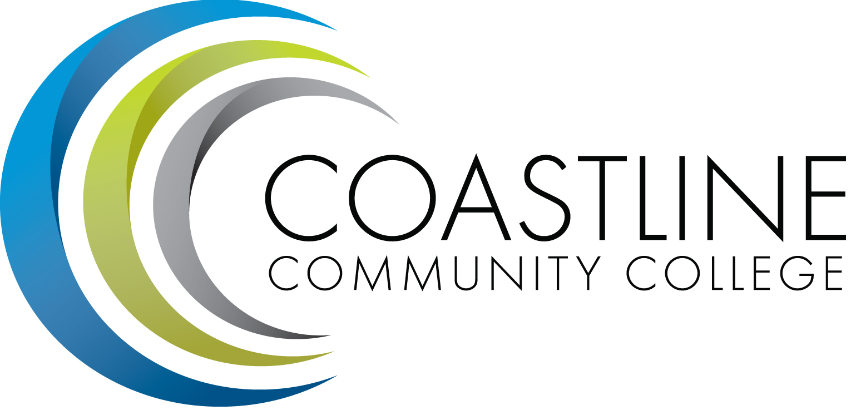
Planning, Institutional Effectiveness, and Accreditation Committee (PIEAC)
April 13, 2016
1:30 p.m. to 3:30 p.m.
Fourth Floor Conference Room

- CALL TO ORDER
  - Roll Call
  - Welcome
  - Adoption of Agenda
  - Approval of Minutes: March 23, 2016

- DISCUSSION ITEMS
2.1 Committee Evaluation A. Zentner
2.2 Educational Master Plan Objective Development Team A. Zentner

5. STANDING REPORTS
5.1 Accreditation V. Rodriguez
5.2 Budget Committee R. Lockwood
5.3 Program Review A. Zentner
5.4 Grants D. Aistrich
5.5 President’s Report L. Adrian
5.6 Wing Reports V. Rodriguez, C. Nguyen, R. Miyashiro
5.7 College Council V. Rodriguez
5.8 Facilities C. Nguyen
5.9 Contract Education J. Groot
5.10 Student Success Committee D. Pittaway
5.11 Other Committees Committee

6. ANNOUNCEMENTS (1-2 minutes per)

6. ADJOURNMENT

